

MASENO 2025 KCSE PREDICTION
CONFIDENTIAL EXAM
443/2
AGRICULTURE
PAPER 2
TIME: 2 HOURS

NAME……………………………………………………………………………………….
SCHOOL……………………………………………… SIGN………………………..
INDEX NO……………………………………………. ADM NO……………………

(Kenya Certificate of Secondary Education)

INTRODUCTION TO CANDIDATES
- Write your name and index number, in the spaces provided above.
- This paper consists of three sections A, B and C.
- Answer all questions in section A and B.
- Answer any two questions in section C.
- Check and ascertain that all pages are printed
- All answer must be in English.

SECTION | QUESTION | MAX SCORE | CANDIDATES SCORE
A | 1 – 22 | 30
B | 23-26 | 20
C |  | 20  20
TOTAL SCORE |  | 90

SECTION A (30MARKS)
Answer all the questions in this section in the spaces provided
- Name a breed of camel with two humps (1/2mks)
…………………………………………………………………………………………………………

- State two types of roughages as used in livestock nutrition (1mk)
…………………………………………………………………………………………………………
…………………………………………………………………………………………………………

- Give two reasons why it is advisable to dehorn cattle (1mk)
…………………………………………………………………………………………………………
…………………………………………………………………………………………………………
…………………………………………………………………………………………………………

- Give three properties of clean milk (1¹/₂mks)
…………………………………………………………………………………………………………
…………………………………………………………………………………………………………
…………………………………………………………………………………………………………

- Name the tool or equipment used to carry out the following routine livestock practices
- Castration (1/2mks)
…………………………………………………………………………………………………………
- Vaccination (1/2mks)
…………………………………………………………………………………………………………
- What is the role of iron in livestock nutrition? (1mk)
…………………………………………………………………………………………………………
…………………………………………………………………………………………………………

- List two importance of fish farming in Kenya (1mk)
…………………………………………………………………………………………………………
…………………………………………………………………………………………………………

- Name two hormones that in fluence milk let-down in dairy cattle (1mk)
…………………………………………………………………………………………………………
…………………………………………………………………………………………………………

- Name two exotic breeds of dairy goats reared in Kenya (1mk)
…………………………………………………………………………………………………………
…………………………………………………………………………………………………………

- What is the role of a crop in the digestion system of poultry? (2mks)
…………………………………………………………………………………………………………
…………………………………………………………………………………………………………

- Name two zoonotic diseases of livestock (1mk)
…………………………………………………………………………………………………………
…………………………………………………………………………………………………………

- Give four routine practices carried out during calf rearing (2mks)
…………………………………………………………………………………………………………
…………………………………………………………………………………………………………
…………………………………………………………………………………………………………
…………………………………………………………………………………………………………

- State two factors that determine the amount of water required by an animal (1mk)
…………………………………………………………………………………………………………
…………………………………………………………………………………………………………

- List three methods of outbreeding as used in livestock nutrition (1¹/₂mks)
…………………………………………………………………………………………………………
…………………………………………………………………………………………………………
…………………………………………………………………………………………………………

- Outline four conditions necessary for artificial incubation (2mks)
…………………………………………………………………………………………………………
…………………………………………………………………………………………………………
…………………………………………………………………………………………………………
…………………………………………………………………………………………………………

- List three sources of lipids in livestock diet (1¹/₂mks)
…………………………………………………………………………………………………………
…………………………………………………………………………………………………………
…………………………………………………………………………………………………………

- Name two parasites of bees (1mk)
…………………………………………………………………………………………………………
…………………………………………………………………………………………………………

- State four qualities of an ideal calf pen (2mks)
…………………………………………………………………………………………………………
…………………………………………………………………………………………………………
…………………………………………………………………………………………………………
…………………………………………………………………………………………………………

- Give four reasons why stones are good as construction materials (2mks)
…………………………………………………………………………………………………………
…………………………………………………………………………………………………………
…………………………………………………………………………………………………………
…………………………………………………………………………………………………………

- Name a disease transmitted by the following vectors (1mk)
- Tsetse fly ……………………………………………………..
- Brown ear tick ……………………………………………………..

- List four requirements in a deep litter house (2mks)
…………………………………………………………………………………………………………
…………………………………………………………………………………………………………
…………………………………………………………………………………………………………
…………………………………………………………………………………………………………

- Give two causes of soft shells in eggs (2mks)
…………………………………………………………………………………………………………
…………………………………………………………………………………………………………
…………………………………………………………………………………………………………

SECTION B (20MKS)
Answer all questions in this section in the spaces provided
- Study the diagram and answer questions that follow.
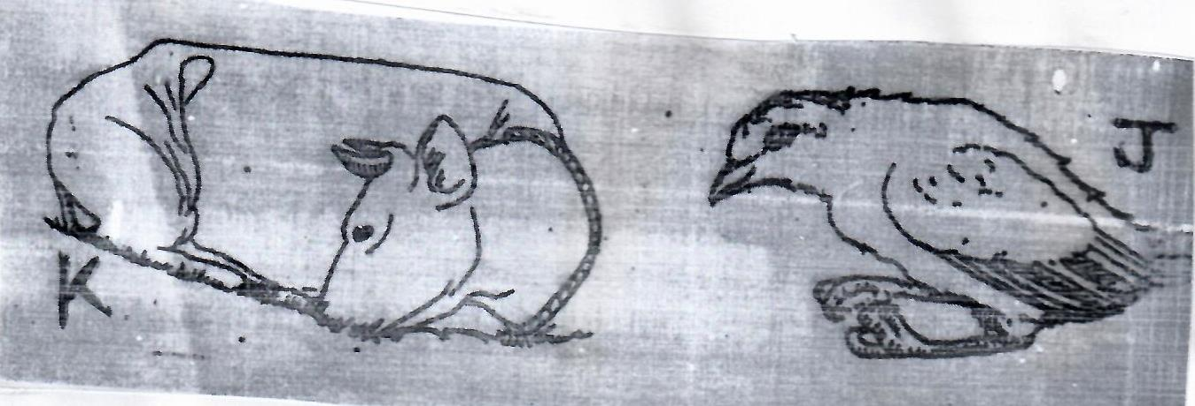
- Identify the condition or deficiency disease as illustrated in J and K above
J ……………………………………………………………………………(1mk)
K ……………………………………………………………………………(1mk)

- Name cause of the deficiency condition in
J …………………………………………………………………………….(1mk)
K ……………………………………………………………………………(1mk)

- Give one remedy to control condition K in lactating cows (1mk)
…………………………………………………………………………………………………………
…………………………………………………………………………………………………………

- Below is a diagram illustrating a farm implement. Study it and answer the questions that follow.
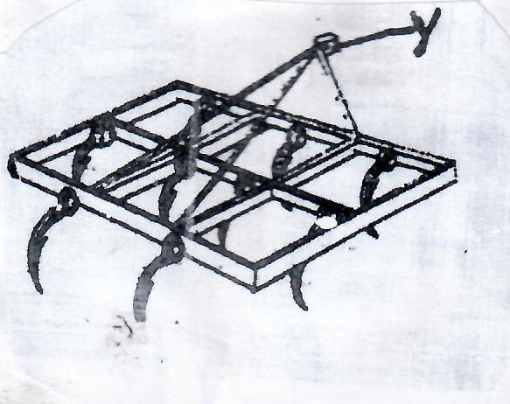
- Identify the implement (1mk)
………………………………………………………………………………………………………………………………………………………………………………………………………………
- State:
- The role of the part labelled Y (1mk)
………………………………………………………………………………………………………………………………………………………………………………………………………………
- Three uses of the implement on the farm (3mks)
…………………………………………………………………………………………………………………………………………………………………………………………………………………………………………………………………………………………………………………………………………………………………………………………………………………………...…
- List two maintenance practices carried out on the implement (2mks)
………………………………………………………………………………………………………………………………………………………………………………………………………………………………………………………………………………………………………..……………

- The diagram below represents methods of identifications in livestock. Use them to answer questions that follow.
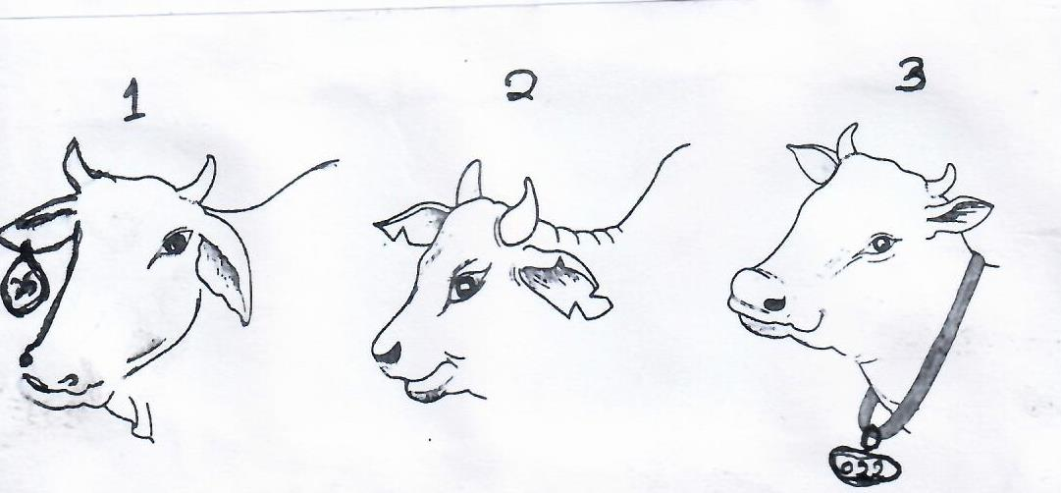
- Name the three methods shown above (1¹/_{2mks})
…………………………………………………………………………………………………………
…………………………………………………………………………………………………………
…………………………………………………………………………………………………………

- State three importance of identification method shown above (1¹/₂mks)
…………………………………………………………………………………………………………
…………………………………………………………………………………………………………
…………………………………………………………………………………………………………

- The diagram below illustrates a common practice in poultry production
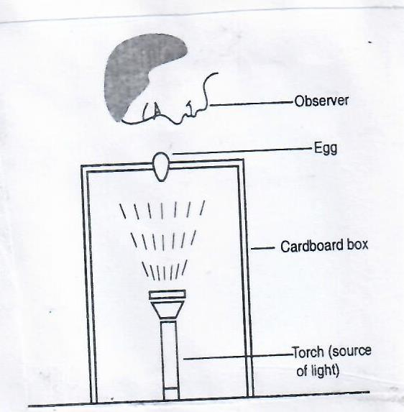

- Identify the practice (1mk)
…………………………………………………………………………………………………………

- Give abnormalities of eggs that can be observed using the above illustrated practice (4mks)
…………………………………………………………………………………………………………
…………………………………………………………………………………………………………
…………………………………………………………………………………………………………
…………………………………………………………………………………………………………
…………………………………………………………………………………………………………

SECTION C(40MKS)
(Answer any two questions from this section)
- a) Discuss causes and control of cannibalism in poultry. (10mks)
b) Highlight various measures that famers undertake to control tapeworms (5mks)
c) Explain the importance of streaming up in dairy cattle (5mks)

28. a) Describe the precautions undertaken while handling farm tools and equipment(10mks)
b) Discuss contagious abortion disease under the following sub headings:
- Animals attacked (2mks)
- Casual organism (2mks)
- Symptoms (2mks)
- Control measures (4mks)

- a) Discuss the structural and functional differences between petrol and diesel engines (10mks)
b) Describe general characteristics of indigenous cattle breeds (5mks)
- Outline five general methods of disease control in livestock (5mks)

